SUMMERVILLE CREDIT UNION · CONSOLIDATED MEMBER GUIDE · CSUM-20 of 30
Inbox & Message Center

Module: nFinia Digital Banking > Inbox
Sources: Summerville Reports Series A (36 docs) + Series B (25 docs) | Features: nFinia Documentation Features Spreadsheet
01 PRODUCT SUMMARY

The Inbox & Message Center is the in-app communication hub between members and the credit union. It consolidates two distinct types of messages: system notifications about account activities and transactions (Notifications tab), and secure two-way support messages exchanged with credit union staff (Support Messages tab).
Unlike email — which is transmitted in plaintext and is inherently insecure for financial information — the Message Center operates entirely within the authenticated nFinia session. Members can send secure inquiries, receive replies from CU staff, view full conversation history, and track the status of any open support requests without leaving digital banking.
A notification badge on the Inbox icon in the Dashboard navigation shows unread message count, drawing members back into the platform. All messages and notifications are encrypted in transit and at rest.

At a Glance

Attribute | Detail
Module | Inbox
Notification Types | Account activity alerts, transfer confirmations, eDocument notices
Support Messages | Two-way authenticated messaging with CU staff
Security | Encrypted, authenticated — secure for financial discussion
New Message | Members can initiate support requests directly from Inbox
Related Reports | CSUM-19 (Alerts), CSUM-25 (Settings)

02 KEY USE CASES

Use Case | Who Uses It | What They Do | Business Value
Review Notifications | Members checking recent account activity | Open Inbox > Notifications for all recent system alerts | Consolidated notification history without navigating account by account
View Support Conversation | Members following up on past inquiry | Open Inbox > Support Messages to see conversation thread | No need to call the CU to reference a prior support exchange
Send Support Request | Members with account questions | Click New Message to submit a secure support inquiry | Async, secure support channel that avoids phone hold times
Track Form Submission | Members checking form status | Look for form submission confirmation in Inbox notifications | Inbox confirms when a submitted form has been received and processed

03 STEP-BY-STEP GUIDE

Navigation: Dashboard > Inbox (bell/envelope icon in top navigation).

Step 1 — Start from Dashboard
The member begins at the Dashboard after logging in. The Dashboard displays all account balances, upcoming payments, quick-action tiles, and the top navigation bar with links to Accounts, Move Money, and More.
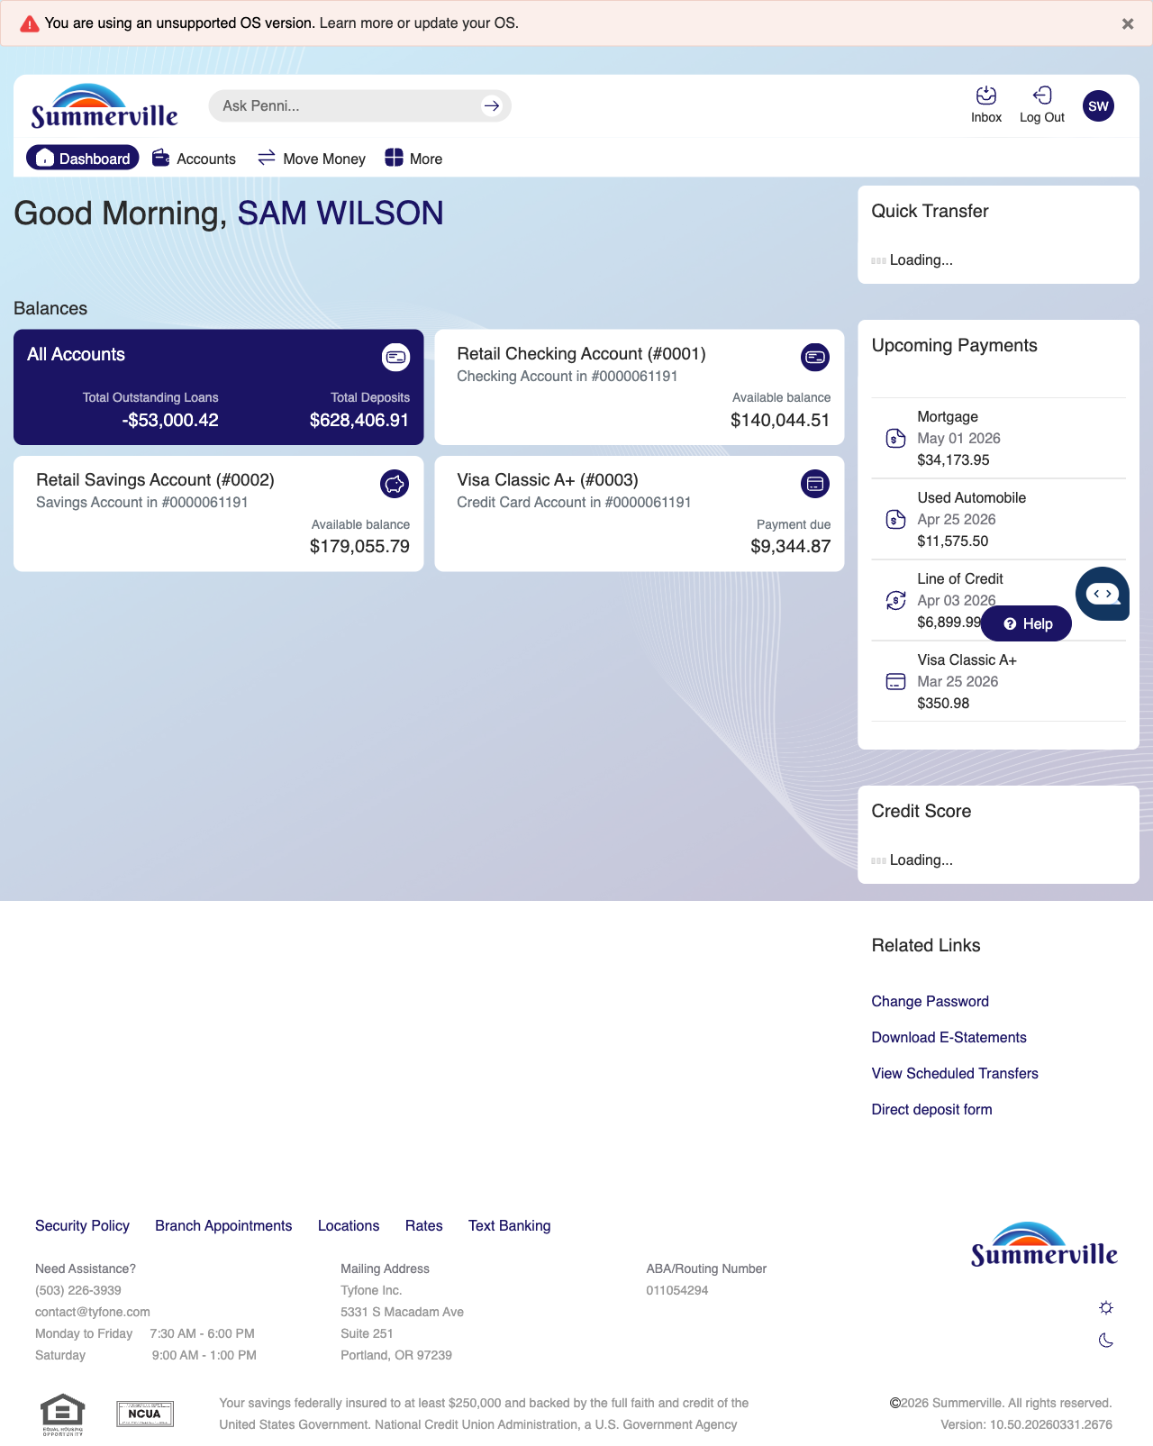
Step 1: Start from Dashboard

Step 2 — Open the More Menu
The member clicks ‘More’ in the top navigation bar. The More options panel expands to show additional features: Check Deposit, User ID and Password, eDocuments, Account Alerts, General Alerts, Password, Forms, One-Time Passcode, Skip A Pay, Do-Not-Disturb, Manage Devices, My Insights, Alert Settings, Recent Activities, and Card Services.
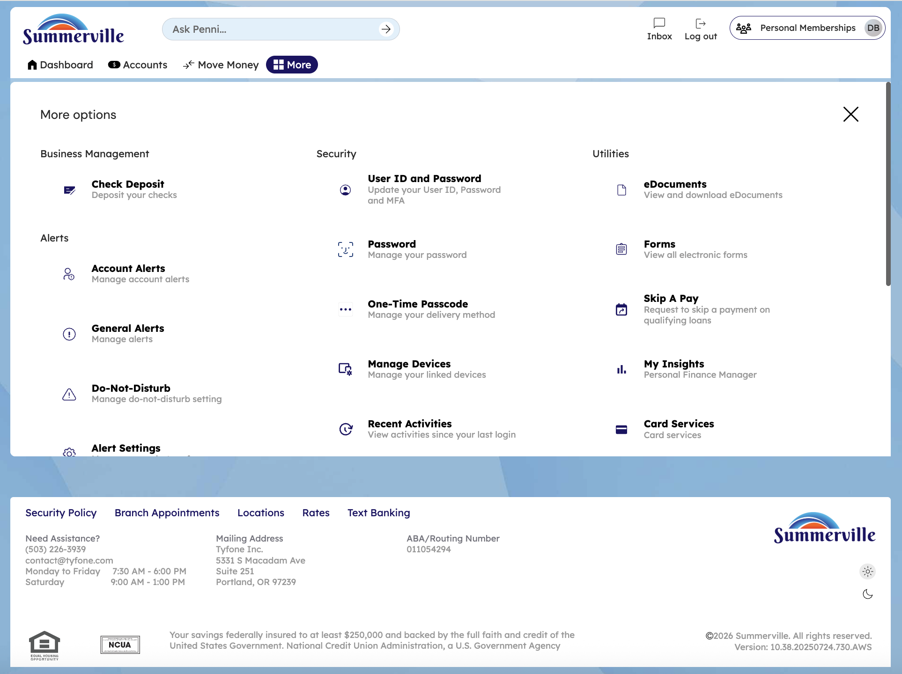
Step 2: More Menu

Step 3 — Navigate from Dashboard to Inbox
The Inbox page displays a list of support tickets in a table format with columns for ID, Subject, Last Updated, Assigned To, and Status. Tickets include Account Inquiry, Transaction Inquiry, and General inquiries.
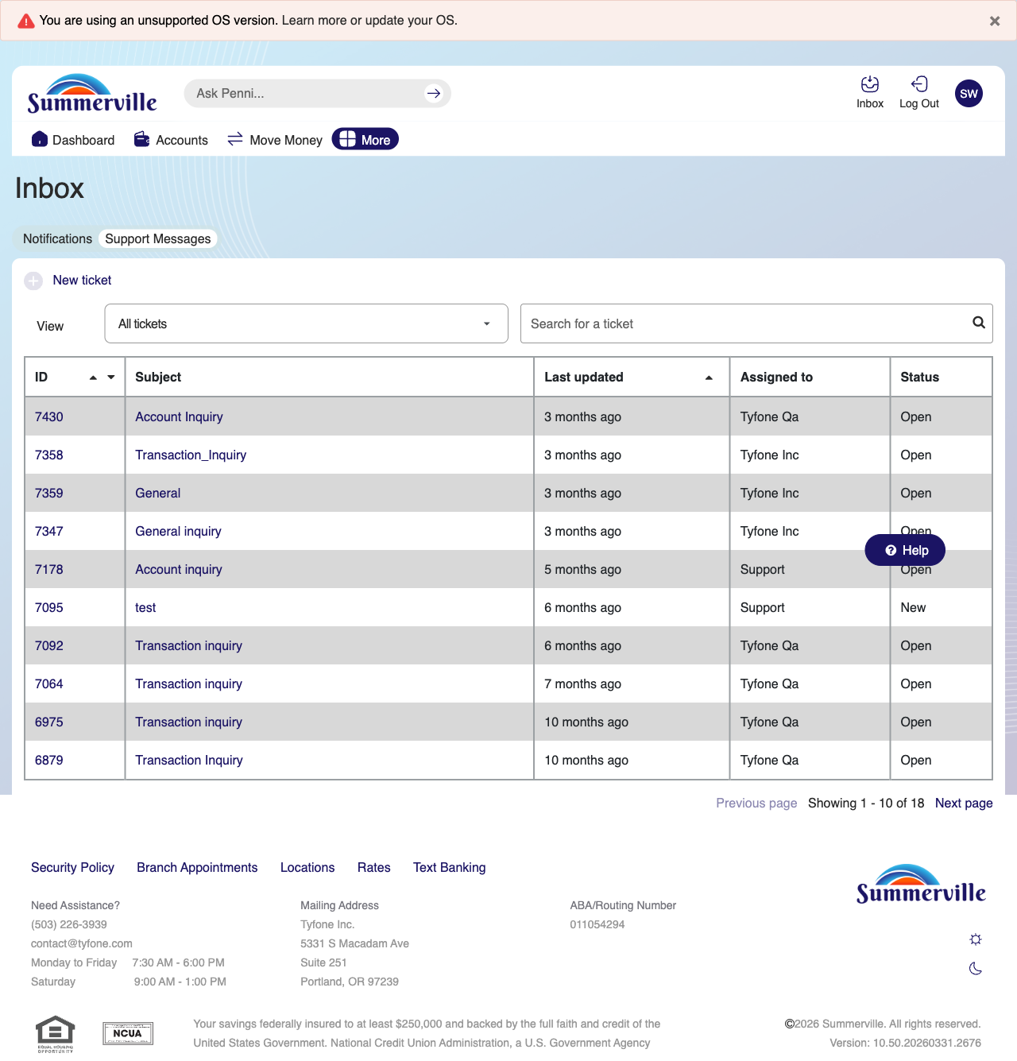
Step 3: Navigate from Dashboard to Inbox

Step 4 — View Support Messages
The Inbox interface shows the support messages view with a table listing various support tickets and their details including status and assigned representative.
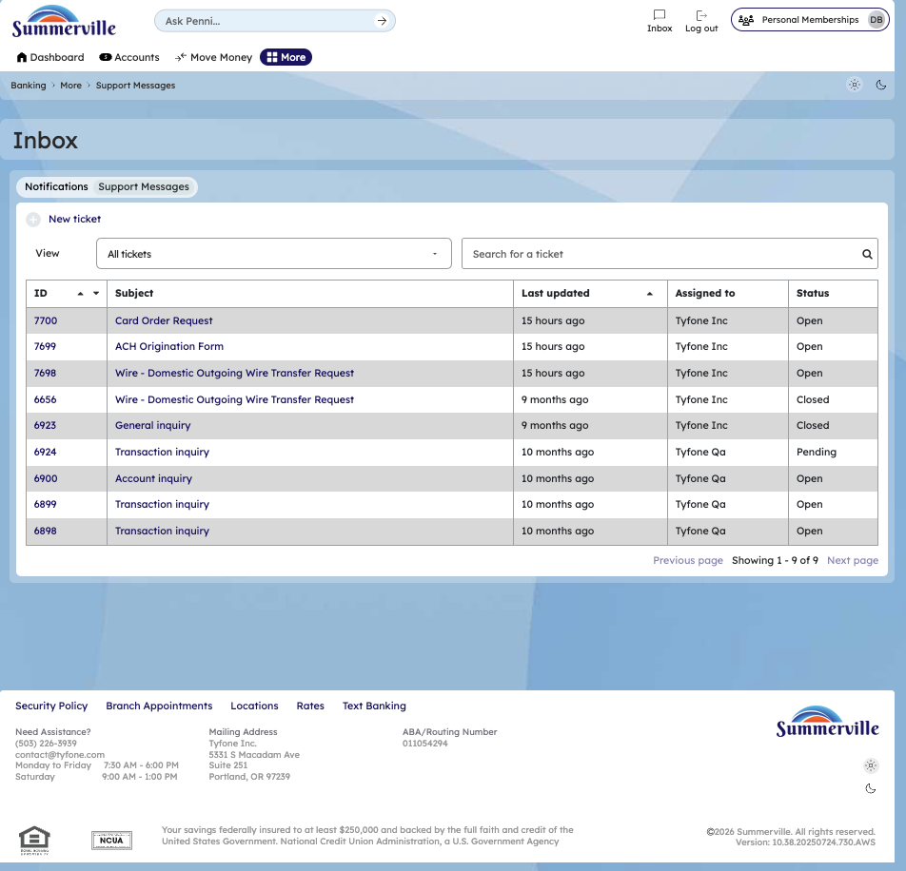

Step 4: View Support Messages

Step 5 — Send a New Support Message
A 'Create New Ticket' modal is displayed with fields for Inquiry Type (set to General Inquiry), Subject, Message body, and a file attachment option with a 20 MB size limit.
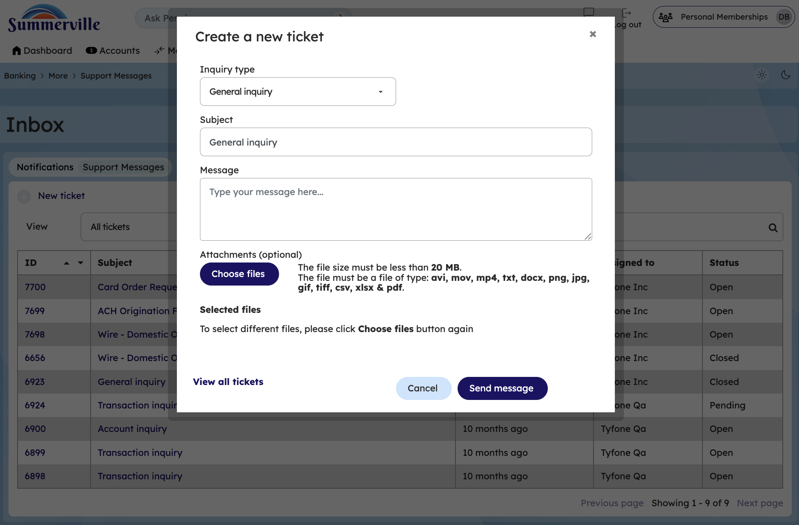
Step 5: Send a New Support Message

Step 6 — Reply to a Support Thread
A success message modal confirms the ticket was created successfully with ID 07703. The list of recently created support tickets is visible in the background.
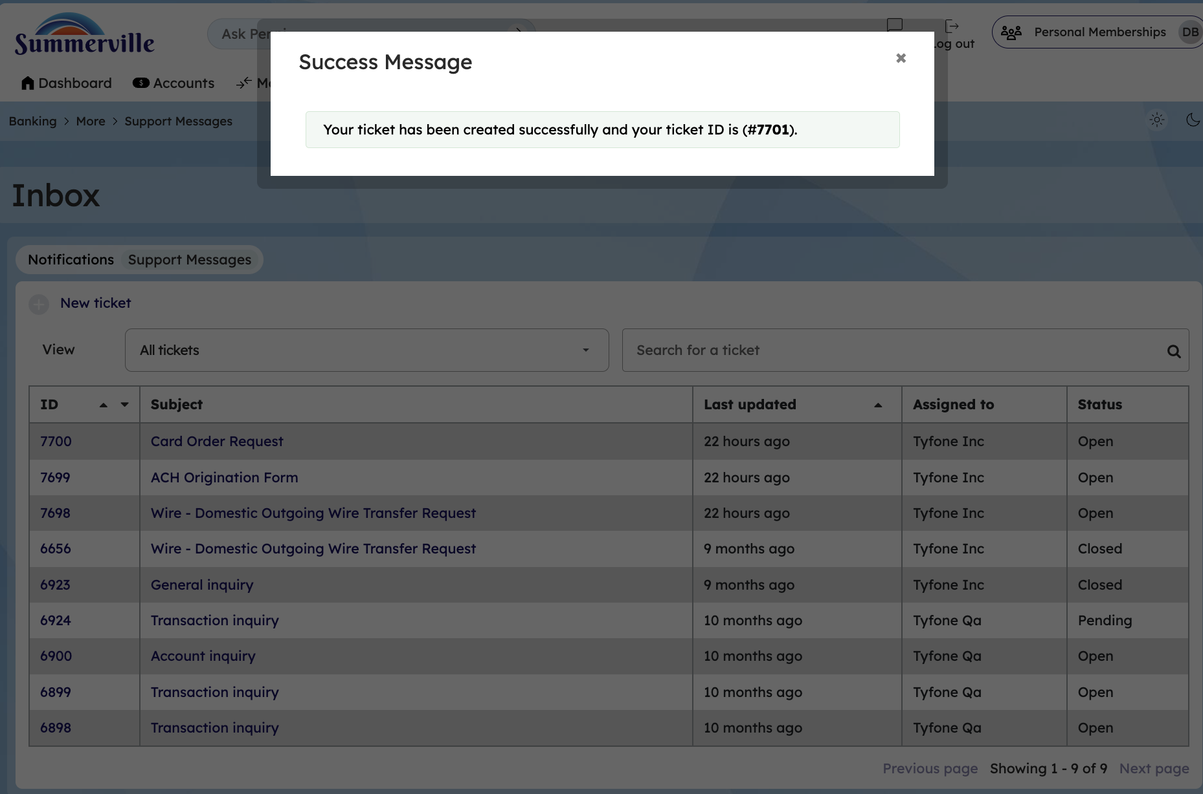
Step 6: Reply to a Support Thread
Step 7 — Click on Help button on bottom left
On clicking help we get 2 options lets talk and message us
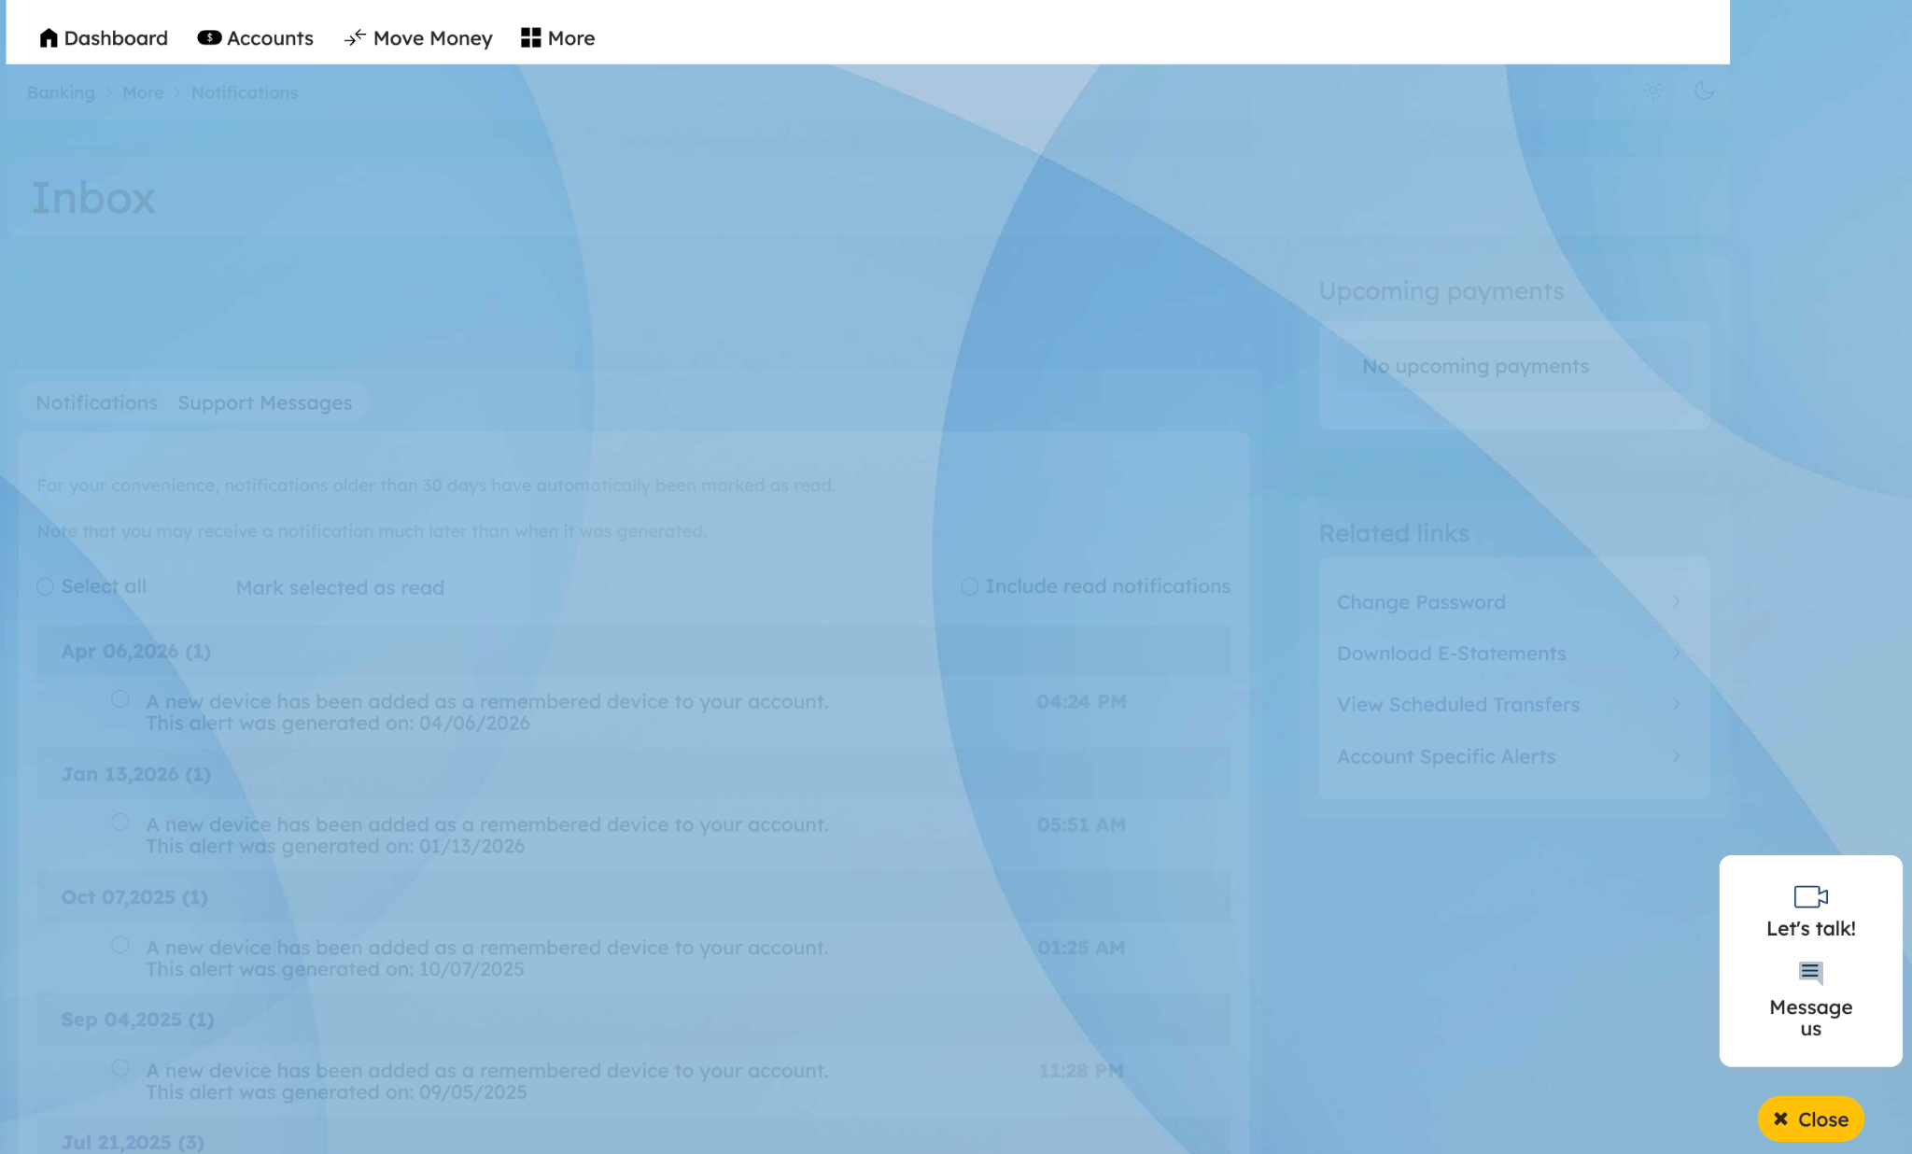
Step 8 — Click on Lets talk
On clicking talk now we get an option to send a message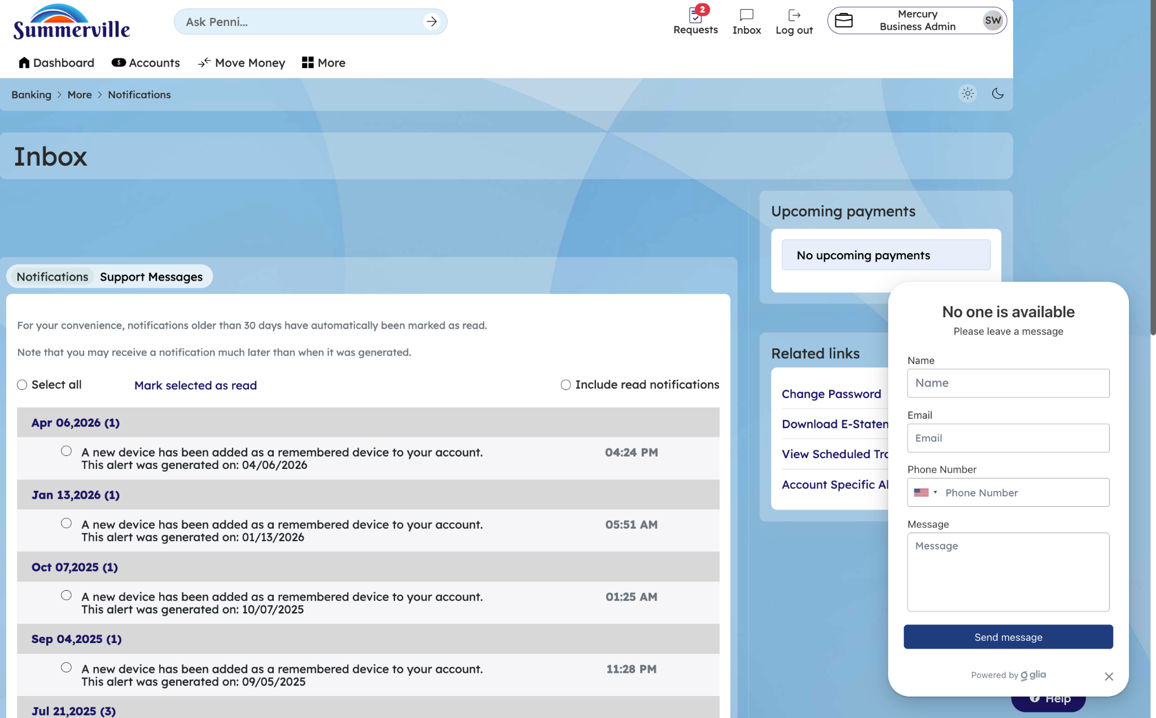
Step 9 — Click on message us
A 'Create New Ticket' modal is displayed with fields for Inquiry Type (set to General Inquiry), Subject, Message body, and a file attachment option with a 20 MB size limit.
